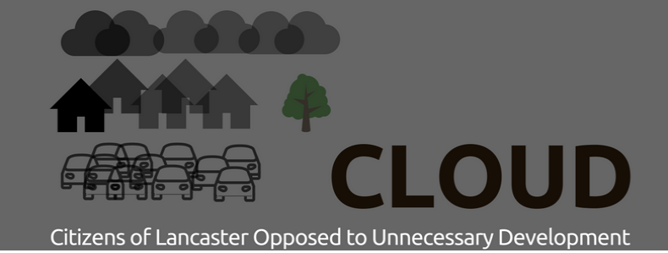

CLOUD: 2022 ANNUAL GENERAL MEETING

The 2022 CLOUD Annual General Meeting will be held on:
Wednesday 26thOctober 2022 at 7.30pm.
Venue Rowley Court, Scotforth .
Rowley Court is directly opposite the Boot & Shoe at the Scotforth traffic lights. Limited car parking is available, but if this is full you can use the adjacent Booth’s car-park. Rowley Court will be open from 7pm.

We decided that it would be helpful to hold a face to face meeting rather than running our AGM on Zoom as it is 3 years since we were able to do this.We hope that members will be able attend for an update on CLOUD activities.

AGENDA
1. Approval of the minutes of the last Annual General Meeting held on 20nd October 2021.
2. Report by the Chairperson on CLOUD’s activities over the year from October 2021.
3. Report by the Treasurer on CLOUD’s finances.
4. Election of the new Management Committee for the year to October 2022.

5. Next Steps
6. Date of Next Meeting.

The CLOUD constitution and minutes of meetings (including the 2020 AGM) are all available on our website
Here is a direct link to 2021 AGM Reports and Minutes
The reports by the Chairperson and Treasurer for agenda items 2 and 3 will be issued in a further Newsbrief.

Regarding agenda item 4 (Election of the new Management Committee) all of these posts are for election by CLOUD members at this AGM. The Management Committee comprises Chairperson, Treasurer and Secretary, plus up to six other members. Any CLOUD member wishing to stand for any of these posts should submit their name before 19th October 2022 to the Secretary by email to cloudbgv2017@gmail.com.

Present members of the CLOUD Management Committee are:

Chairperson: Tom Wilkinson
Secretary: Rosemary Hindley
Treasurer: Tony Breakell
Other Members:
Mary Breakell (IT, Web and Communications)
Mark Salisbury (Burrow representative)
Heather Willes
Barbara Walker
Tony Blendall
Sally Salisbury

For agenda item 6 (Any Other Business) we invite CLOUD members to submit any proposals they wish to have discussed at the AGM.

Best wishes
Mary Breakell on behalf of the CLOUD team

